**PROJECT REPORT**

**SMART WASTE MANAGEMENT SYSTEM FOR METROPOLITAN CITIES**

# TEAM ID: PNT2022TMID17711

|  |  |
| --- | --- |
| **ROLL NUMBER** | **NAME** |
| 713319EC091 | RAVISHANKAR C |
| 713319EC068 | MOTHIPRASATH M K |
| 713319EC069 | NAVANEETHAKRISHNAN K |
| 713319EC062 | PRADEEPRAJAN R |

**CONTENT**

1. **INTRODUCTION**
   1. Project Overview
   2. Purpose
2. **LITERATURE SURVEY**
   1. Existing problem
   2. References
   3. Problem Statement Definition
3. **IDEATION & PROPOSED SOLUTION**
   1. Empathy Map Canvas
   2. Ideation & Brainstorming
   3. Proposed Solution
   4. Problem Solution fit
4. **REQUIREMENT ANALYSIS**
   1. Functional requirement
   2. Non-Functional requirement
5. **PROJECT DESIGN**
   1. Data Flow Diagrams
   2. Solution & Technical Architecture
   3. User Stories
6. **PROJECT PLANNING & SCHEDULING**
   1. Sprint Planning & Estimation
   2. Sprint Delivery Schedule
   3. Reports from JIRA
7. **CODING & SOLUTIONING**
   1. Feature 1
   2. Feature 2
   3. Feature 3

**8. TESTING**

8.1 Test Cases

8.2 User Acceptance Testing

**9. RESULTS**

9.1 Performance Metrics

**10. ADVANTAGES & DISADVANTAGES**

**11. CONCLUSION**

**12. FUTURE SCOPE**

**13. APPENDIX**

Source Code

GitHub & Project Demo Link

**ABSTRACT**

One issue that most cities and municipalities are dealing with currently, is the degradation of environmental cleanliness with reference to waste management. This is a result of improper garbage collection management. Dumping garbage onto the streets and in public areas is a common synopsis found in all developing countries and this mainly ends up affecting the environment and creating several unhygienic conditions. To avoid improper garbage management and to create a hygienic environment, the concept of automation is used in waste management system. Any city being referred to as a "smart city" is because of its orderly and tidy surroundings. But currently, many issues including those related to smart grids, smart environments, and smart living are faced. Today, cities and metropolitan areas' top priority is proper garbage management.

Traditional waste management techniques are too simplistic to create an effective and reliable waste management. The ideology put forward includes hardware and software technologies i.e. connecting Wi-Fi system to the normal dustbin in order to provide free internet facilities to the user for a particular period of time. The technology awards the user for keeping the surrounding clean and thus work hand in hand for the proper waste management in a locality. The smart bin uses multiple technologies - firstly the technology for measuring the amount of trash dumped and secondly the movement of the waste and lastly sending necessary signals and connecting the user to the Wi-Fi system. The proposed system will function on client server model, a cause that will assure clean environment, good health, and pollution free society.

**1. INTRODUCTION**

**1.1 Project Overview**

Our waste generation is constantly growing to form a global garbage crisis. Even though we indulge in creating a more sustainable and greener, we still fail to handle our waste generation and management. Combining technology support with a vision of social, economic and environmental sustainability is the best way out of this problem. It is done in the following manner. The smart bin system undergoes a thorough system check and battery level monitoring in order to function efficiently. If the battery level is found to be low, it has to be recharged immediately, else it can proceed to the next step. The threshold level levels of the bin are indicated my multiple sensors attached to bin. If the garbage exceeds the level, then an alert message is sent to the garbage collectors as well as to the municipality or area administration. The area in which garbage is found to overflow is allocated to respective garbage collectors in the form of messages through GSM system. Once the waste bin is emptied, an information update is sent to the municipality and server is updated. This is how the waste from bins can be efficiently handled and managed using technology which in turn keeps the environment clean and healthy.

**1.2 Purpose**

We amalgamate technology along with waste management in order to effectively create a safe and a hygienic environment. Smart waste management is about using technology and data to create a more efficient waste industry. Based on IoT (Internet of Things) technology, smart waste management aims to optimize resource allocation, reduce running costs, and increase the sustainability of waste services. This makes it possible to plan more efficient routes for the trash collectors who empty the bins, but also lowers the chance of any bin being full for over a week. A good level of coordination exists between the garbage collectors and the information supplied via technology. This makes them well aware of the existing garbage level and instigate them whenever the bins reach the threshold level. They are sent with alert messages so that they can collect the garbage on time without littering the surrounding area. The fill patterns of specific containers can be identified by historical data and managed accordingly in the long term. In addition to hardware solutions, mobile applications are used to overcome the challenges in the regular waste management system, such as keeping track of the drivers while they are operating on the field. Thus, smart waste management provides us with the most optimal way of managing the waste in an efficient manner using technology.

**2. LITERATURE SURVEY**

**2.1 Existing problem**

Around 80% of waste collections happen at the wrong time. Late waste collections lead to overflowing bins, unsanitary environments, citizen complaints, illegal dumping, and increased cleaning and collection costs. Early waste collections mean unnecessary carbon emissions, more traffic congestion, and higher running costs. The old way of doing waste management is highly inefficient. And in today’s ever-technological world, an innovative and data-driven approach is the only way forward. Traditionally, municipalities and waste management companies would operate on a fixed collection route and schedule. This means that waste collection trucks would drive the same collection route and empty every single waste container – even if the waste container did not need emptying. This means high labour and fuel costs – which residents ultimately foot the bill for.

**2.2 Reference**

|  |  |  |  |  |
| --- | --- | --- | --- | --- |
| **SI. No** | **Title** | **Year** | **Author** | **Inference** |
| **1.** | IOT-Based route Recommendation for an Intelligent Waste Management System | 2022 | Mohammad Hossein ghahramani | It also maintains a good diversity in a newly generated population. The main drawback of the state of art was that it cannot appropriately model the association among spatial objects, consequently find an optimal route. |
| **2.** | Smart waste bin Management | 2022 | Parthasarathi Manickaraja | Uses the Ultrasonic sensor to level the dustbin and also uses the GSM module. Provides an alert message once the level has reached to the authority. |
| **3.** | Smart waste management using IOT | 2020 | Tejashree Kadus | Technology used is a load cell and a Wi-Fi module Segregate the waste in the dustbin and provides and alert message. |
| **4.** | Real time solid waste bin monitoring system framework using wireless sensor network | 2019 | Thiyagapriyadharshini | Smart bin based on a microcontroller based platform Arduino which is interfaced with GSM module.  Waste management efficiency and it avoids lumping of wastes. |
| **5.** | Smart waste collection system | 2018 | Muhamad JavedRamzan | Technology based on sensor based collection and uses route algorithm.It identifies the status of waste bin levels along with the location to replace the bin. |
| **6.** | Waste management and tracking | 2017 | B Keerthana | Technology based on ZigBee. Less expensive Lock based System with acknowledgment alert system. |
| **7.** | Smart Waste Management for Green Environment | 2016 | T. P. Fei | The system is based on Bootstrap platform. This system works on the waterfall methodology which has 4 crucial phases: planning and analysis, system design, system implementation and system testing. Using this system, operators can get the information regarding collection from trash bins. The limitations of this approach are that the resultant product has a short life and uniformity is lost after a certain period. |

**2.3 Problem Statement Definition**

|  |  |  |  |  |  |
| --- | --- | --- | --- | --- | --- |
| **Problem Statement (PS)** | **I am (Customer)** | **I’m trying to** | **But** | **Because** | **Which makes me feel** |
| PS-1 | Householder | Dispose the vegetable waste and other household wastes. | It increases the land pollution and contaminate ground water. | To keep the surrondings  clean and healthy. | Difficult |
| PS-2 | Industrialist | Dispose the chemical wastes and recycle for future use | It contaminates wildlife’s habitats and endangers the life of people at large. | To avoid risk for both environment and human health. | Unpleasant |

**3. IDEATION & PROPOSED SOLUTION**

**3.1 Empathy map canvas**

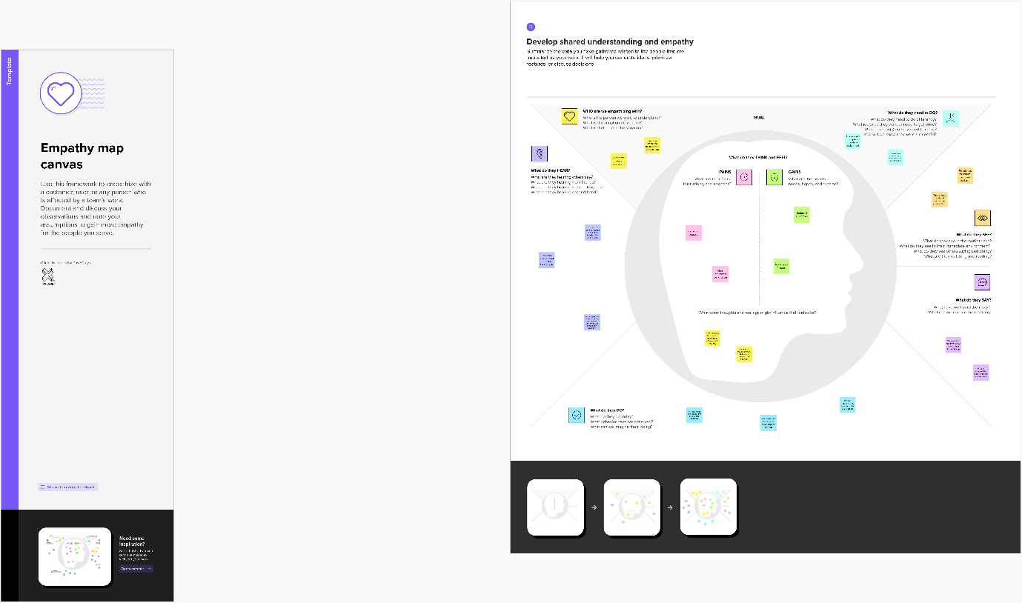

**3.2 IDEATION AND BRAINSTROMING**

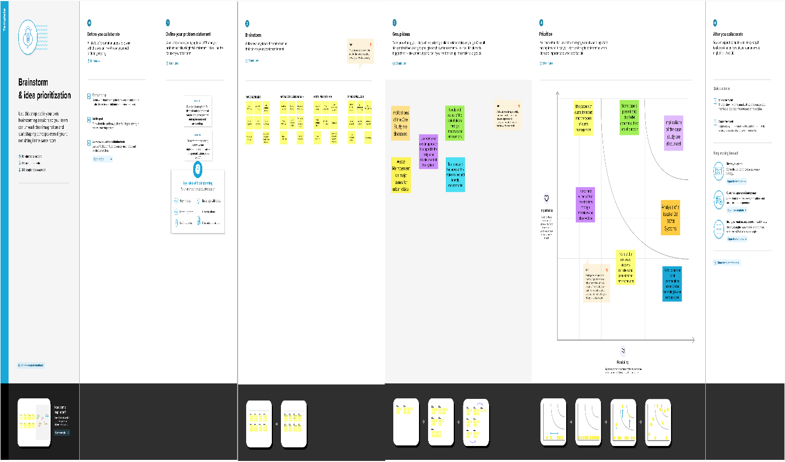

**3.3 PROPOSED SOLUTION**

|  |  |  |
| --- | --- | --- |
| **S.No.** | **Parameter** | **Description** |
|  | Problem Statement (Problem to be solved) | ❖Rubbish and waste can cause air and water pollution.  ❖ Rotting garbage is also known to produce harmful gases mix with the air and cause breathing problem in people.  ❖ Due to improper waste disposal, we may face several problems like unpleasant odor and health problems. |
|  | Idea / Solution description | ❖ Using sensors when a trash bin is about to fill,the authorities are immediately notified and collection trucks can be scheduled for a picup even before the pre-scheduled time.  ❖ Collect and analyse area-specific data on waste volumes for better planning. |
|  | Novelty / Uniqueness | ❖ Identify potential waste streams.  ❖ Create a waste management-focused community outreach plane. |
|  | Social Impact / Customer Satisfaction | ❖ Monitoring the amount of waste and periodic collection reduce the environmental damage and improve street sanitation.  ❖ Raise public awarness of utilizing renewable resources. |
|  | Business Model (Revenue Model) | ❖ It generates revenue through the provision of various waste management and disposal services.  ❖ Recycling solutions to residential, commercial, industrial, and municipal clients |
|  | Scalability of the Solution | ❖ Selects the optimum routes for waste collection trucks.  ❖ Installing more bins fir collecting recyclables like paper, glass, plastic. |

**3.4 PROBLEM SOLUTION FIT**

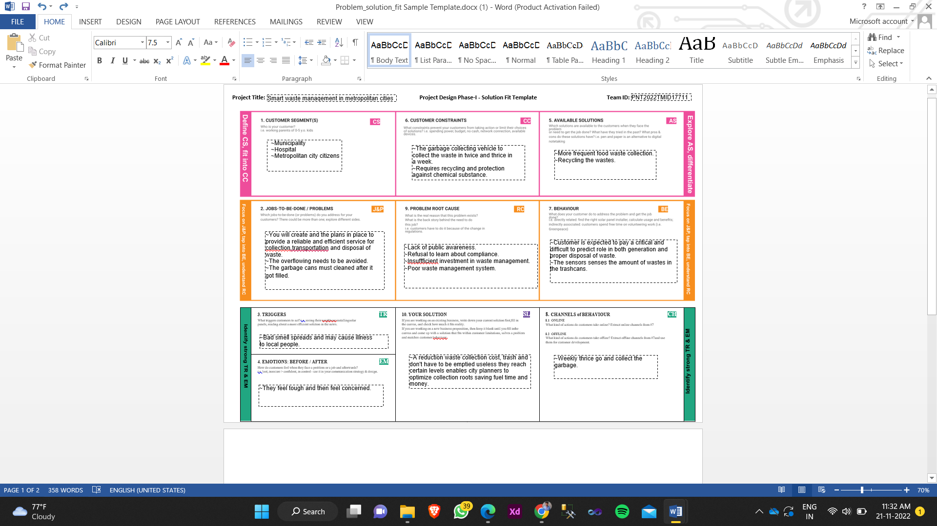

**4. REQUIREMENT ANALYSIS**

**4.1 Functional Requirement**

|  |  |  |
| --- | --- | --- |
| **FR No.** | **Functional Requirement (Epic)** | **Sub Requirement (Story / Sub-Task)** |
| FR-1 | Detailed bin inventory | Bins or stands are visible on the map as green, orange, or red circles. You can see bin details in the Dashboard – capacity, waste type, last measurement, GPS location and collection schedule or pick recognition. |
| FR-2 | Real time bin monitoring | The Dashboard displays which displays all the real-time data on filling levels of bins monitored by smart sensors. Along to the percentage of fill level, based on the previous data, the tool predicts when the bin will become full, one of the functionalities that are not included even in the best waste management software. Sensors recognize picks as well; so you can check when the bin was collected last.  With the help of real-time data and predictions, you can eliminate the overflowing bins and stop collecting half empty ones. |
| FR-3 | Expensive bins | We help you identify bins that drive up your collection costs. The tool calculates a rating for each bin in terms of collection costs.  The tool considers the average distance depo-bin discharge in the area. The tool assigns bin a rating (1 -10) and calculates distance from depo-bin discharge. |
| FR-4 | Adjust bin distribution | Ensure that the most optimal distribution of bins and Identify areas with either dense or sparse bin distribution. Make sure that all trash types are represented within a stand. Based on the previous data, you can adjust bin capacity or location where ever necessary. |
| FR-5 | Eliminate inefficient picks | Removing the collection of half-empty bins. By using real time data on fill-levels and pick recognition, we can show you how full the bins can be collected. |
| FR-6 | Plan waste collection routes | The tool semi-automates waste collection route planning. Based on current bin fill-levels and predictions of reaching full capacity, you are ready to respond and schedule waste collection.  You can compare planned vs. executed routes to identify any inconsistencies. |

**4.2 Non-Functional requirements**

|  |  |  |
| --- | --- | --- |
| **FR No.** | **Non-Functional Requirement** | **Description** |
| NFR-1 | **Usability** | IoT device verifies that usability is a special and important perspective to analyze user requirements, which can further improve the design quality. In the design process with user experience as the core, the analysis of users' product usability can indeed help designers better understand users' potential needs in waste management, behavior and experience. |
| NFR-2 | **Security** | Use a reusable bottles.  Use reusable grocery bags.  Purchase wisely and recycle.  Avoid single use food and drink containers. |
| NFR-3 | **Reliability** | Smart waste management is also about creating  better working conditions for waste collectors and drivers. Instead of driving the same collection routes and servicing empty bins, waste collectors will spend their time more efficiently, taking care of bins that need servicing. |
| NFR-4 | **Performance** | The Smart Sensors use ultrasound technology to  measure the fill levels (along with other data) in bins several times a day. Using a variety of loT networks ( (NB - IoT, GPRS), the sensors send the data to Sensoneo's Smart Waste Management Software System, a powerful cloud-based platform, for data driven daily operations, available also as a waste management app.  Customers are hence provided data-driven decision making, and optimization of waste collection routes, frequencies, and vehicle loads resulting in route reduction by at least 35%. |
| NFR-5 | **Availability** | By developing & deploying resilient hardware and beautiful software we empower cities, businesses, and countries to manage waste smarter. |
|  |  |  |
| NFR-6 | **Scalability** | Using smart bins may reduce the number of bins inside the cities because we monitor the garbage  24/7 more efficiently. |

**5. PROJECT DESIGN**

**5.1 Data Flow Diagram**

A rapid rise in inhabitants across the globe has led to the inadmissible management of waste in various countries, giving rise to various health issues and environmental pollution. The waste-collecting trucks collect waste just once or twice in seven days. Due to improper waste collection practices, the waste in the dustbin is spread on the streets.

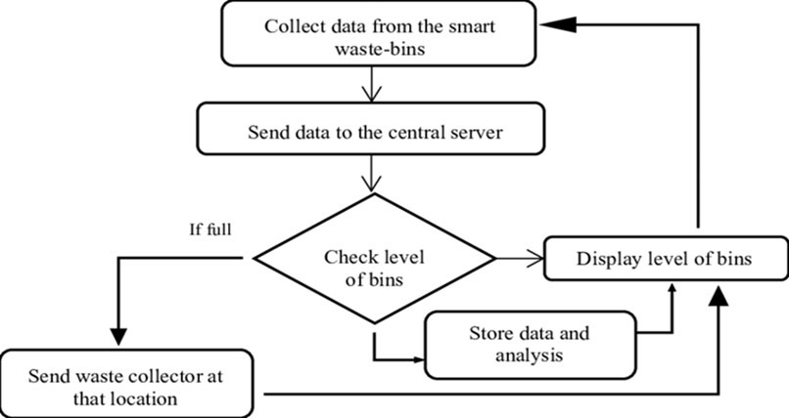

**5.2 Technical Architecture**

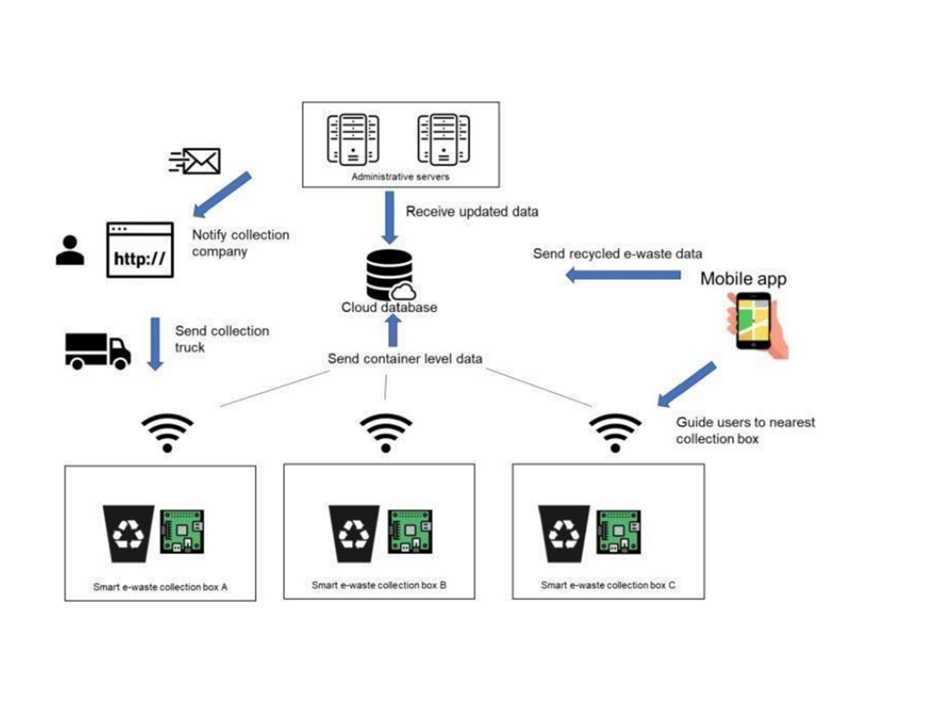

**Table-1 : Components & Technologies**

|  |  |  |  |
| --- | --- | --- | --- |
| **S.No** | **Component** | **Description** | **Technology** |
|  | User Interface | IOT cloud platform /WEB PORTAL | HTML, CSS, NODE RED, JAVASCRIPT/MQTT PROTOCOL |
|  | Application Logic-1 | The bin waste data's are collected using sensor | Python/Ultrasonic sensor |
|  | Application Logic-2 | The data which is collected are monitored using IOT | IBM Watson STT Service |
|  | Application Logic-3 | To Get the location of the garbage | GPS |
|  | Database | MySQL is a relational database that is based on a tabular design.  NoSQL is non-relational and has a document based design. | MySQL, NoSQL |
|  | Cloud Database | Database service on cloud | IBM DB2, IBM Cloud etc.. |
|  | File Storage | File storage requirements | IBM Block Storage, local file system |
|  | External API-1 | External APIs expose a project's internal resources  to outside users or applications | IBM Weather API, etc.. |
|  | External API-2 | External API allow you to access third party resources that are available through RESTful web services | Aadhar API, etc.. |
|  | Machine Learning Model | The proper algorithm makes planning good.  It will guide the goodness character and which path should be taken and which garbage bin should be collected first | Python IDLE or Anaconda navigator or Jupiter |
|  | Infrastructure (Server / Cloud) | Application Deployment on Local System / Cloud  Cloud Server Configuration:  Cloud deployment is the process of deploying an application through one or more hosting models-software as a service (SaaS), platform as a service (PaaS) and or infrastructure as a service (laaS) that leverage the cloud  Local Server Configuration :  A local server gives you exclusive access to data and objects in a set of Windows folders called data directories | Cloud server- MySQL  Local server- HTTP |

**Table-2: Application Characteristics:**

| **S.No** | **Characteristics** | **Description** | **Technology** |
| --- | --- | --- | --- |
|  | Open-Source Frameworks | Micro web framework, Written in Python | Flask |
|  | Security Implementations | Provides Security rules to allow asses to data | Fire base, fire walls |
|  | Scalable Architecture | New features can be added | Node RED |
|  | Availability | Web application can be accessed from anywhere. | IBM Watson IOT platform, HTML, CSS, JavaScript |
|  | Performance | Provides real time data to web application which uses cloud platform and alerts garbage collector.  All truck drivers can access the application at same time | Cloudant DB IBM Watson IOT platform |

* 1. **User Stories**

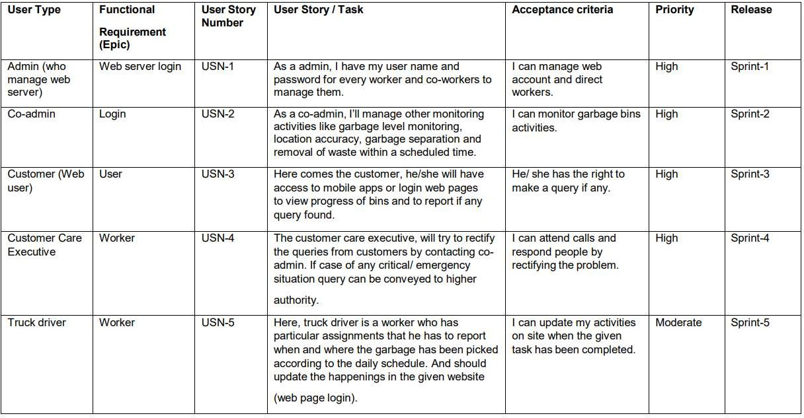

**6. PROJECT PLANNING & SCHEDULING**

**6.1 Sprint Planning & Estimation**

|  |  |  |  |  |  |  |
| --- | --- | --- | --- | --- | --- | --- |
| **Sprint** | **Functional**  **Requirement (Epic)** | **User Story**  **Number** | **User Story / Task** | **Story Points** | **Priority** | **Team**  **Members** |
| Sprint-1 | Registration | USN-1 | As a user, I can register for the application by entering my email, password and confirming my password. | 10 | High | Ravishankar |
| Sprint-1 | Login | USN-2 | As a user, I will receive confirmation email once I have registered for the application. | 10 | High | Navaneethakr-ishnan |
| Sprint-2 | Dashboard | USN-4 | As a user, I’ll control the waste level by monitoring them via real time web portal. | 10 | High | Mothiprasath |
| Sprint-2 | Notification | USN-4 | As a user, once the bin gets filled, I’ll notify trash truck with location of bin with bin ID. | 10 | High | Pradeeprajan |
| Sprint-3 | Dashboard | USN-5 | As a user , I’II gather all the  waste from the garbage bin and load it onto a truck.. | 10 | Medium | Navaneethakr-ishnan |
| Sprint-3 | Dashboard | USN-6 | As a user, I can specify the location to be monitored and to reach the landfills in optimized routes to save time. | 10 | Medium | Ravishankar |
| Sprint-4 | Dashboard | USN-7 | As a user, I'll make sure everything is proceeding as planned and  without any problems. | 20 | High | Mothiprasath |

|  |  |  |  |  |  |  |
| --- | --- | --- | --- | --- | --- | --- |
| **Sprint** | **Total Story Points** | **Duration** | **Sprint Start Date** | **Sprint End Date (Planned)** | **Story Points Completed (as on**  **Planned End Date)** | **Sprint Release Date (Actual)** |
| Sprint-1 | 20 | 6 Days | 24 Oct 2022 | 29 Oct 2022 | 20 | 29 Oct 2022 |
| Sprint-2 | 20 | 6 Days | 31 Oct 2022 | 05 Nov 2022 | 20 | 05 Nov 2022 |
| Sprint-3 | 20 | 6 Days | 07 Nov 2022 | 12 Nov 2022 | 20 | 12 Nov 2022 |
| Sprint-4 | 20 | 6 Days | 14 Nov 2022 | 19 Nov 2022 | 20 | 19 Nov 2022 |

**6.2 Sprint Delivery Schedule**

|  |  |  |
| --- | --- | --- |
| **Title** | **Description** | **Details** |
| **Literature Survey & Information Gathering** | Literature survey on the selected project & gathering information by referring the, technical papers, research publication etc.. | 28 SEPTEMBER 2022 |
| **Prepare Empathy Map** | Prepare Empathy Map Canvas to capture the user Pains &  Gains, Prepare list of problem Statements. | 24 SEPTEMBER 2022 |
| **Ideation** | List the by organizing the brainstorming session and prioritize the top 3 ideas based on the feasibility & importance. | 25 SEPTEMBER 2022 |
| **Proposed Solution** | Prepare the proposed solution document, which includes the novelty, feasibility of idea, business model, social impact, scalability of solution, etc. | 23 SEPTEMBER 2022 |
| **Problem Solution Fit** | Prepare problem - solution fit  Document. | 30 SEPTEMBER 2022 |
| **Solution Architecture** | Prepare solution architecture  Document. | 28 SEPTEMBER 2022 |
| **Customer Journey** | Prepare the customer journey maps to understand the user interactions & experiences  with the application (entry to exit). | 20 OCTOBER 2022 |

|  |  |  |
| --- | --- | --- |
| **Functional Requirements** | Prepare the functional  requirement document. | 26 OCTOBER 2022 |
| **Data Flow Diagrams** | Draw the data flow diagrams and  submit for review. | 27 OCTOBER 2022 |
| **Technology Architecture** | Prepare the technology  architecture diagram. | 28 OCTOBER 2022 |
| **Prepare Milestone & Activity**  **List** | Prepare the milestones &  activity list of the project. | 04 November 2022 |
| **Project Development - Delivery of Sprint-1, 2, 3 & 4** | Develop & submit the developed code by testing it. | 10 November 2022 |

**6.3 Reports from JIRA**

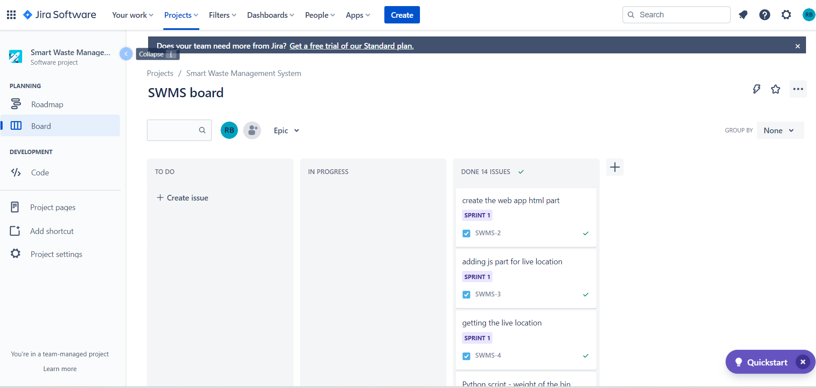

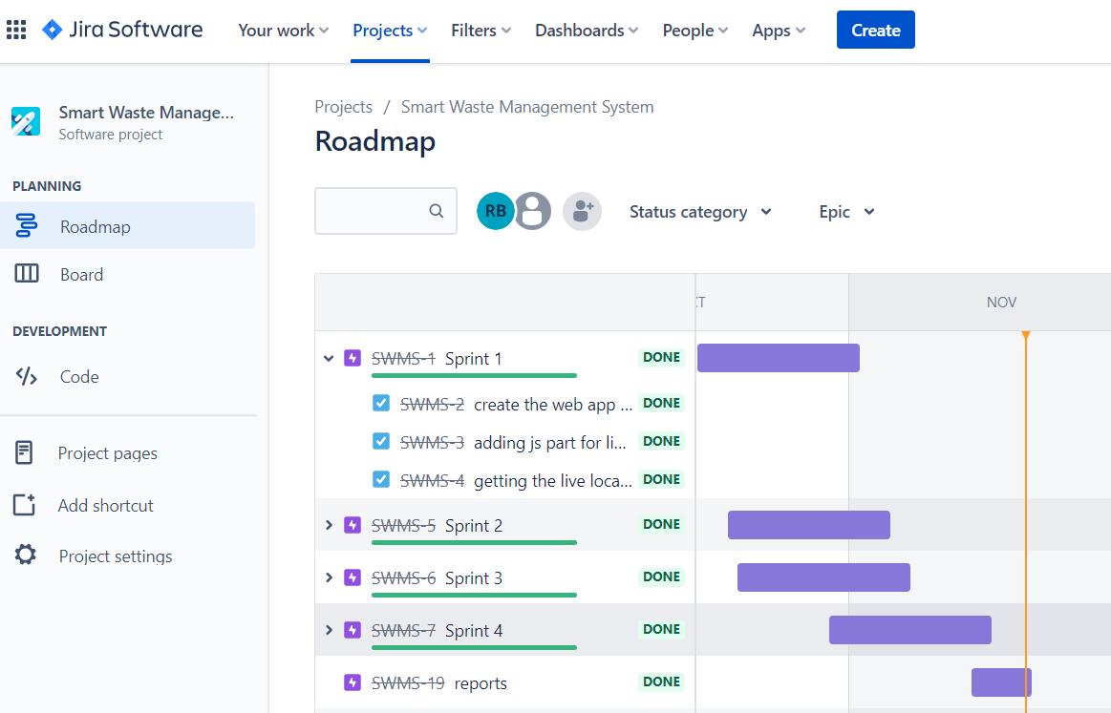

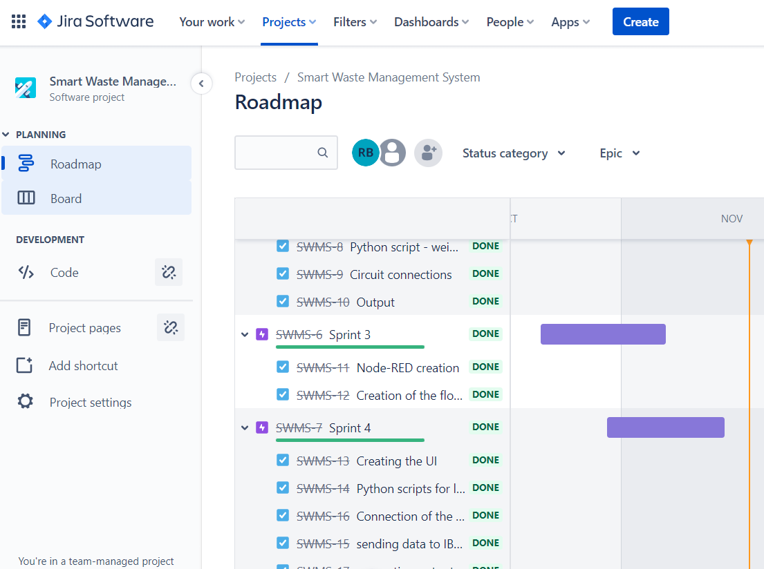

**7. CODING AND SOLUTIONING**

**7.1 Feature 1**

#include <WiFi.h> // library for wifi

#include <PubSubClient.h> // library for MQTT

#include <LiquidCrystal_I2C.h>

#include <mjson.h>

LiquidCrystal_I2C lcd(0x27, 20, 4);

//----------------------- credentials of IBM Accounts ------------------------------

#define ORG "9gbe4w" // IBM organisation id

#define DEVICE_TYPE "SWMSMC" // Device type mentioned in ibm watson iot platform

#define DEVICE_ID "ibmproject" // Device ID mentioned in ibm watson iot platform

#define TOKEN "sUNA41tG6-Pq)0rk5X" // Token

//----------------------- customise above values -----------------------------------------------------

char server[] = ORG ".messaging.internetofthings.ibmcloud.com"; // server name

char publishTopic[] = "iot-2/evt/data/fmt/json"; // topic name and type of event perform and format in which data to be send

char topic[] = "iot-2/cmd/led/fmt/String"; // cmd Represent type and command is test format of strings

char authMethod[] = "use-token-auth"; // authentication method

char token[] = TOKEN;

char clientId[] = "d:" ORG ":" DEVICE_TYPE ":" DEVICE_ID; //Client id

//---------------------------------------------------------------------------------------------------------------------

WiFiClient wifiClient; // creating instance for wificlient

PubSubClient client(server, 1883, wifiClient);

#define ECHO_PIN 12

#define TRIG_PIN 13

float dist;

String data3;

bool SealBin = true;

void setup()

{

Serial.begin(115200);

pinMode(LED_BUILTIN, OUTPUT);

pinMode(TRIG_PIN, OUTPUT);

pinMode(ECHO_PIN, INPUT);

//pir pin

pinMode(34, INPUT);

//ledpins

pinMode(23, OUTPUT);

pinMode(2, OUTPUT);

pinMode(4, OUTPUT);

pinMode(15, OUTPUT);

lcd.init();

lcd.backlight();

lcd.setCursor(1, 0);

lcd.print("");

wifiConnect();

mqttConnect();

}

float readcmCM()

{

digitalWrite(TRIG_PIN, LOW);

delayMicroseconds(2);

digitalWrite(TRIG_PIN, HIGH);

delayMicroseconds(10);

digitalWrite(TRIG_PIN, LOW);

int duration = pulseIn(ECHO_PIN, HIGH);

return duration * 0.034 / 2;

}

void loop()

{

lcd.clear();

publishData();

delay(500);

if (!client.loop())

{

mqttConnect(); // function call to connect to IBM

}

}

/* --------------------------------retrieving to cloud-----------------------------------------------------*/

void wifiConnect()

{

Serial.print("Connecting to ");

Serial.print("Wifi");

WiFi.begin("Wokwi-GUEST", "", 6);

while (WiFi.status() != WL_CONNECTED)

{

delay(500);

Serial.print(".");

}

Serial.print("WiFi connected, IP address: ");

Serial.println(WiFi.localIP());

}

void mqttConnect()

{

if (!client.connected())

{

Serial.print("Reconnecting MQTT client to ");

Serial.println(server);

while (!client.connect(clientId, authMethod, token))

{

Serial.print(".");

delay(500);

}

initManagedDevice();

Serial.println();

}

}

void initManagedDevice()

{

if (client.subscribe(topic))

{

Serial.println("IBM subscribe to cmd OK");

}

else

{

Serial.println("subscribe to cmd FAILED");

}

}

void publishData()

{

float cm = readcmCM();

if(digitalRead(34)) //pir motion detection

{

Serial.println("Motion Detected");

Serial.println("Lid Opened");

digitalWrite(15, HIGH);

if(digitalRead(34)== true)

{

if(cm <= 100) //Bin level detection

{

digitalWrite(2, HIGH);

Serial.println("High Alert!!!,Trash bin is about to be full");

Serial.println("Lid Closed");

lcd.print("Full! Don't use");

delay(2000);

lcd.clear();

digitalWrite(4, LOW);

digitalWrite(23, LOW);

}

else if(cm > 100 && cm < 180)

{

digitalWrite(4, HIGH);

Serial.println("Warning!!,Trash is about to cross 50% of bin level");

digitalWrite(2, LOW);

digitalWrite(23, LOW);

}

else if(cm > 180)

{

digitalWrite(23, HIGH);

Serial.println("Bin is available");

digitalWrite(2,LOW);

digitalWrite(4, LOW);

}

delay(10000);

Serial.println("Lid Closed");

}

else

{

Serial.println("No motion detected");

digitalWrite(2, LOW);

digitalWrite(15, LOW);

digitalWrite(4, LOW);

digitalWrite(23, LOW);

}

}

else

{

digitalWrite(15, LOW);

}

if(cm <= 100)

{

digitalWrite(21,HIGH);

String payload = "{\"High_Alert\":";

payload += cm;

payload += " }";

Serial.print("\n");

Serial.print("Sending payload: ");

Serial.println(payload);

if (client.publish(publishTopic, (char*) payload.c_str())) // if data is uploaded to cloud successfully,prints publish ok else prints publish failed

{

Serial.println("Publish OK");

}

}

else if(cm <= 180)

{

digitalWrite(22,HIGH);

String payload = "{\"Warning\":";

payload += cm ;

payload += " }";

Serial.print("\n");

Serial.print("Sending payload: ");

Serial.println(payload);

if(client.publish(publishTopic, (char*) payload.c_str()))

{

Serial.println("Publish OK");

}

Else

{

Serial.println("Publish FAILED");

}

}

else if(cm > 180)

{

digitalWrite(23,HIGH);

String payload = "{";

payload += cm;

payload += " }";

Serial.print("\n");

Serial.print("Sending payload: ");

Serial.println(payload);

if (client.publish(publishTopic, (char*) payload.c_str())) // if data is uploaded to cloud successfully,prints publish ok else prints publish failed

{

Serial.println("Publish OK");

}

}

float inches = (cm / 2.54); //print on lcd

lcd.setCursor(0,0);

lcd.print("Inches");

lcd.setCursor(4,0);

lcd.setCursor(12,0);

lcd.print("cm");

lcd.setCursor(1,1);

lcd.print(inches, 1);

lcd.setCursor(11,1);

lcd.print(cm, 1);

lcd.setCursor(14,1);

delay(1000);

lcd.clear();

}

//handles commands from user side

void callback(char* subscribetopic, byte* payload, unsigned int payloadLength)

{

Serial.print("callback invoked for topic: ");

Serial.println(subscribetopic);

for (int i = 0; i < payloadLength; i++) {

data3 += (char)payload[i];

}

Serial.println("data: "+ data3);

const char s =(char) data3.c_str();

double pincode = 0;

const char *buf;

int len;

if (mjson_find(s, strlen(s), "$.command", &buf, &len)) // And print it

{

String command(buf,len);

if(command=="\"SealBin\"")

{

SealBin = true;

}

}

data3="";

}

**7.2 Feature 2**

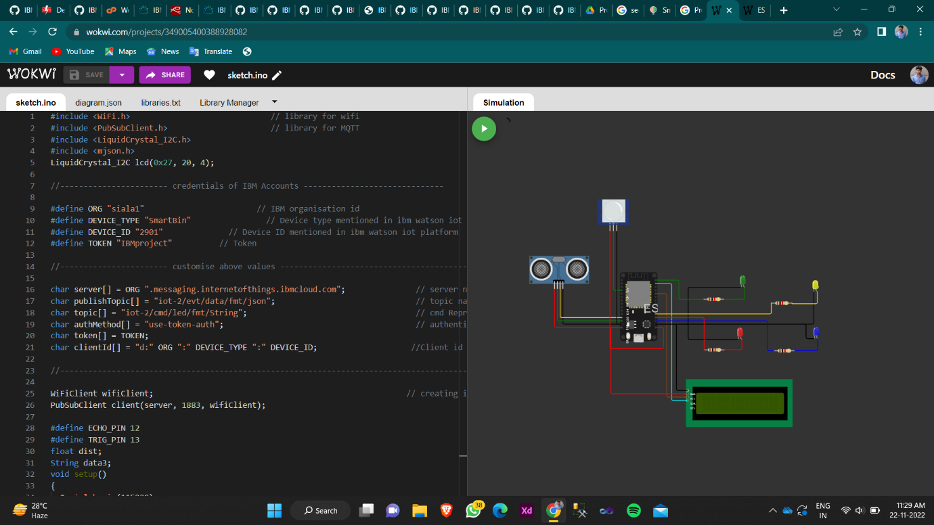

**7.3 Feature 3**

WEBPAGE CODE:

<!DOCTYPE html>

<html lang="en">

<head>

<title>Smart Waste Management System For Metropolitan Cities</title>

<meta charset="UTF-8">

<meta name="viewport" content="width=device-width, initial-scale=1">

<!--==========================================================================

=====================-->

<link rel="icon" type="image/png" href="/static/images/icons/favicon.ico"/>

<!--==========================================================================

=====================-->

<link rel="stylesheet" type="text/css" href="/static/vendor/bootstrap/css/bootstrap.min.css">

<!--==========================================================================

=====================-->

<link rel="stylesheet" type="text/css" href="/static/fonts/font-awesome-4.7.0/css/font-awesome.min.css">

<!--==========================================================================

=====================-->

<link rel="stylesheet" type="text/css" href="/static/fonts/Linearicons-Free-v1.0.0/icon-font.min.css">

<!--==========================================================================

=====================-->

<link rel="stylesheet" type="text/css" href="/static/vendor/animate/animate.css">

<!-- =====================-->

<link rel="stylesheet" type="text/css" href="/static/vendor/css-hamburgers/hamburgers.min.css">

<!-- =====================-->

<link rel="stylesheet" type="text/css" href="/static/vendor/animsition/css/animsition.min.css">

<!--==========================================================================

=====================-->

<link rel="stylesheet" type="text/css" href="/static/vendor/select2/select2.min.css">

<link rel="stylesheet" type="text/css" href="/static/vendor/daterangepicker/daterangepicker.css">

<link href="{{ url_for('static', path='/css/main.css') }}"

rel="stylesheet">

<link href="{{ url_for('static', path='/css/util.css') }}"

rel="stylesheet">

<!-- =====================-->

</head>

<body>

<div class="limiter">

<div class="container-login100" style="background-image: url({{ url_for('static', path='/images/bg1.jpg') }});">

<div class="wrap-login100 p-l-110 p-r-110 p-t-62 p-b-33">

<form class="login100-form validate-form flex-sb flex-w">

<span class="login100-form-title p-b-53"> Sign In With

</span>

<a href="#" class="btn-face m-b-20">

<i class="fa fa-facebook-official"></i> Facebook

</a>

<a href="#" class="btn-google m-b-20">

<img src="static/icons/icon-google.png" alt="GOOGLE"> Google

</a>

<div class="p-t-31 p-b-9">

<span class="txt1"> Username

</span>

</div>

<div class="wrap-input100 validate-input" data-validate = "Username is required">

<input class="input100" type="text" name="username" >

<span class="focus-input100"></span>

</div>

<div class="p-t-13 p-b-9">

<span class="txt1"> Password

</span>

<a href="#" class="txt2 bo1 m-l-5"> Forgot?

</a>

</div>

<div class="wrap-input100 validate-input" data-validate = "Password is required">

<input class="input100" type="password" name="pass" >

<span class="focus-input100"></span>

</div>

<div class="container-login100-form-btn m-t-17">

<button class="login100-form-btn"> Login

</button>

</div>

<div class="w-full text-center p-t-55">

<span class="txt2"> Not a member?

</span>

<a href="#" class="txt2 bo1"> Sign up now

</a>

</div>

</form>

</div>

</div>

</div>

<div id="dropDownSelect1"></div>

<!--==========================================================================

=====================-->

<script src="/static/vendor/jquery/jquery-3.2.1.min.js"></script>

<!--==========================================================================

=====================-->

<script src="/static/vendor/animsition/js/animsition.min.js"></script>

<!--==========================================================================

=====================-->

<script src="/static/vendor/bootstrap/js/popper.js"></script>

<script src="/static/vendor/bootstrap/js/bootstrap.min.js"></script>

<!--==========================================================================

=====================-->

<script src="/static/vendor/select2/select2.min.js"></script>

<!--==========================================================================

=====================-->

<script src="/static/vendor/daterangepicker/moment.min.js"></script>

<script src="/static/vendor/daterangepicker/daterangepicker.js"></script>

<!--==========================================================================

=====================-->

<script src="/static/vendor/countdowntime/countdowntime.js"></script>

<!--==========================================================================

=====================-->

<script src="/static/js/main.js"></script>

</body>

</html>

**WORKING MODEL**

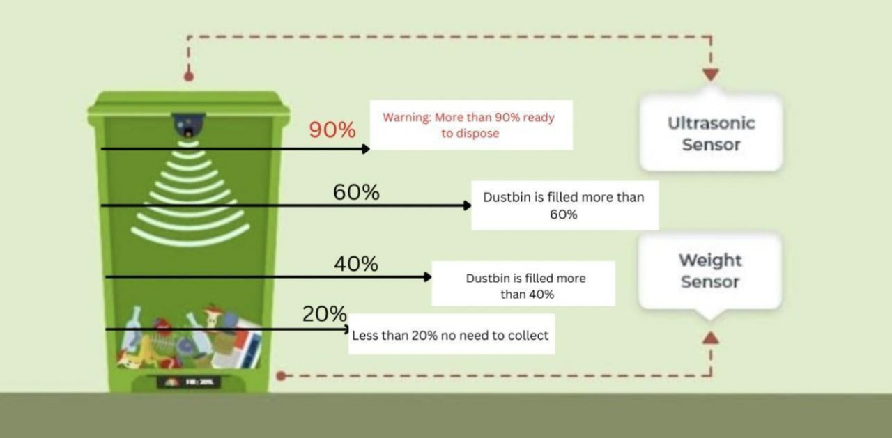

**8. TESTING**

**8.1 TEST CASES**

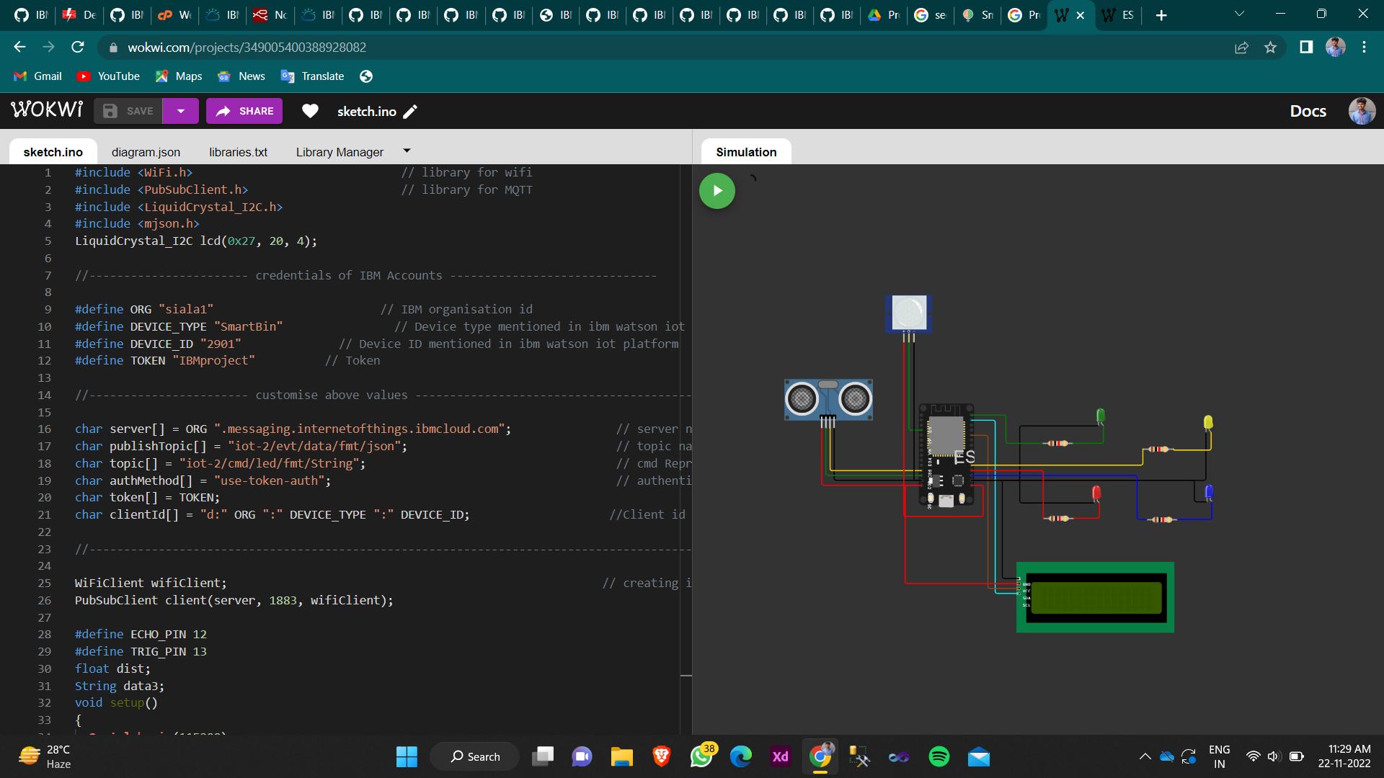

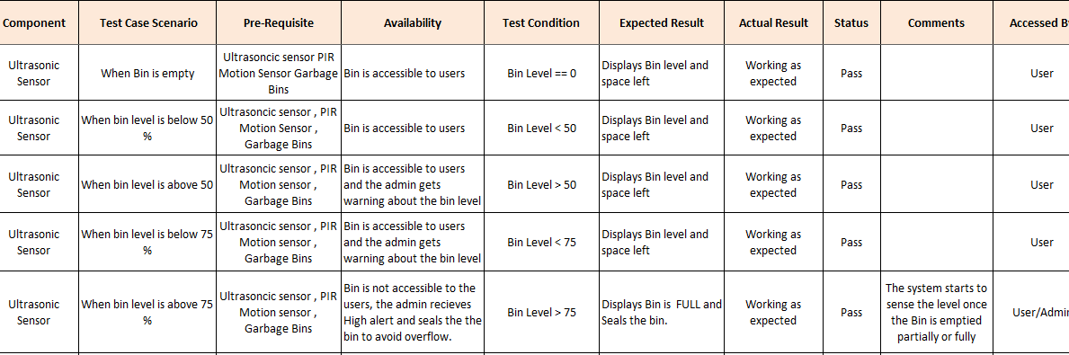

**8.2 USER ACCEPTANCE TESTING**

1. Purpose of Document

The purpose of this document is to briefly explain the test coverage and open issues of the Smart Waste Management System project at the time of the release to User Acceptance Testing (UAT).

2. Defect Analysis

This report shows the number of resolved or closed bugs at each severity level, and how they were resolved.

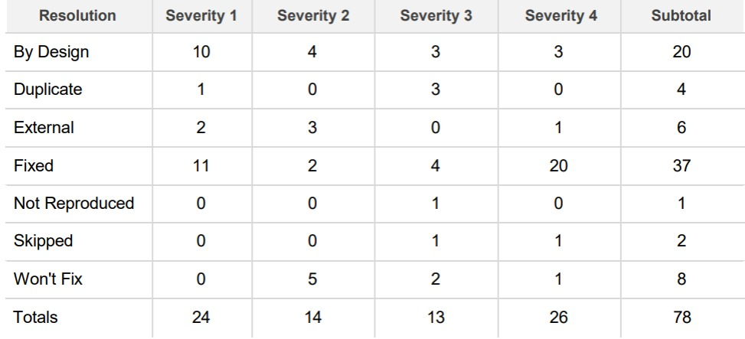

3. TEST CASE ANALYSIS

This report shows the number of test cases that have passed, failed and untested.

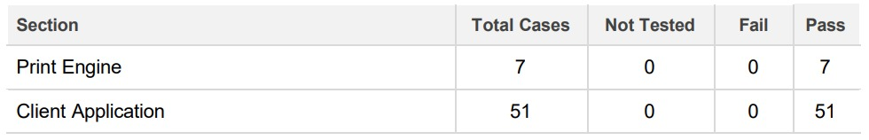

**9. RESULTS**

**9.1 PERFORMANCE METRICS**

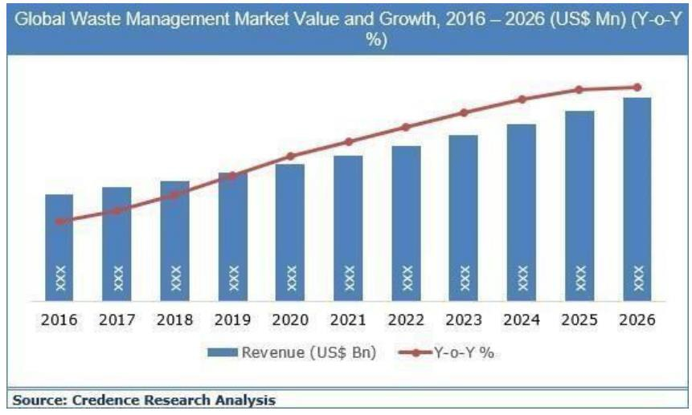

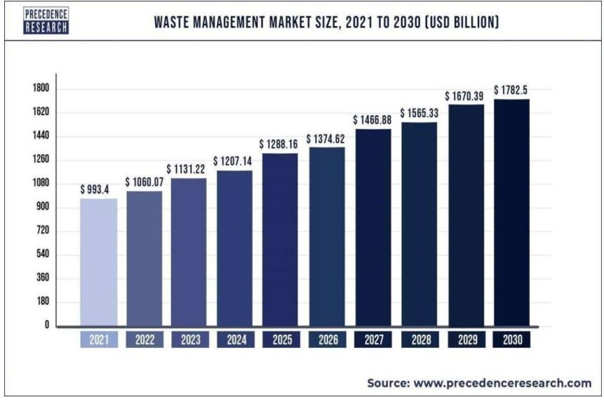

**9.2 ADMIN WEB UI**

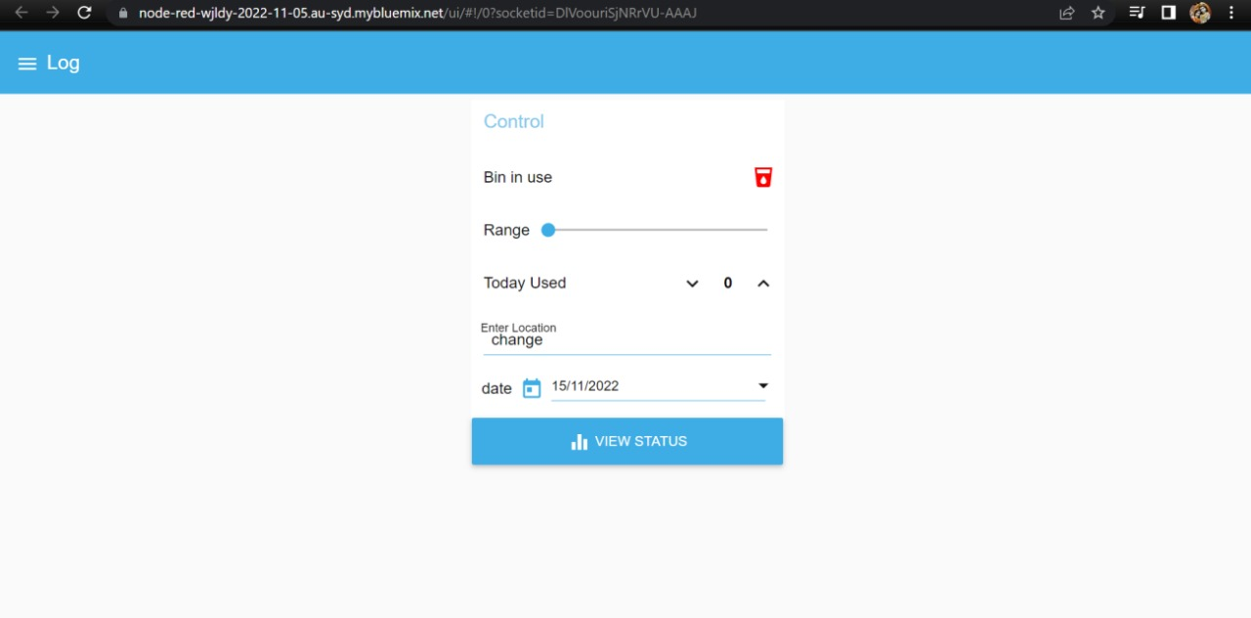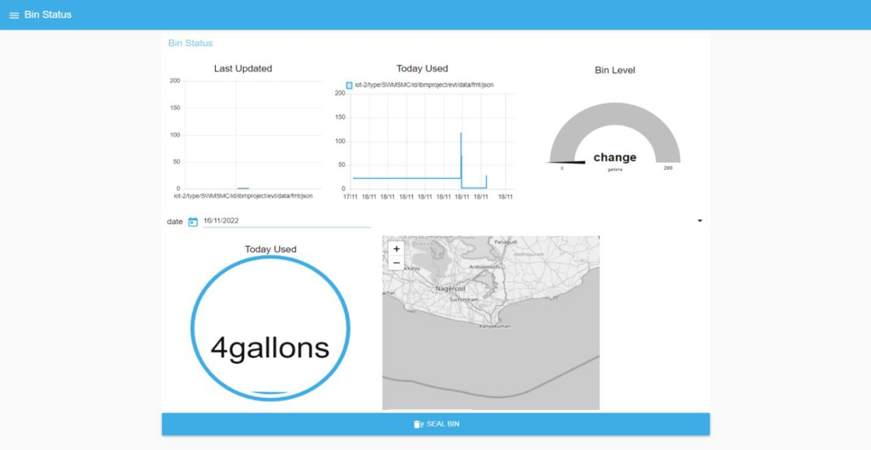

**10. ADVANTAGES & DISADVANTAGES**

**Advantages:**

● People can easily identify the location of the dustbins.

● People can also check for the level of the bin that is being filled.

● Monkeys and other animals would not disturb as we have placed appropriate

sensors.

● Reduction in Collection Cost.

● No Missed Pickups

● Reduced Overflows

● Waste Generation Analysis

● CO2 Emission Reduction

**Disadvantages:**

● Accuracy may be differ due to some unavoidable conditions

● Not at all the features that are impact the production be taken

● System requires a greater number of waste bins for separate waste collection

as per population in the city.

● This results in high initial cost due to expensive smart dustbins compared to

other methods.

● Sensor nodes used in the dustbins have limited memory size.

**11. CONCLUSION**

Improper disposal and improper maintenance of domestic waste create issues in public health and environment pollution thus this paper attempts to provide practical solution towards managing the waste collaborating it with the use of IOT by using the smart waste management system, we can manage waste properly we are also able to sort the Bio-degradable and non-Biodegradable waste properly which reduces the pollution in the environment. Various waste management initiatives taken for human well-being and to improve the TWM practices were broadly discussed in this chapter. The parameters that influence the technology and economic aspects of waste management were also discussed clearly. Different types of barriers in TWM, such as economic hitches, political issues, legislative disputes, informative and managerial as well as solutions and success factors for implementing an effective management of toxic organic waste within a globular context, were also discussed giving some real examples. The effect of urbanization on the environmental degradation and economic growth was also discussed. The proposed system will help to overcome all the serious issues related to waste and keep the environment clean.

**12. FUTURE WORK**

Based on the real-time and historical data collected and stored in the cloud waste collection schedules and routes can be optimized. Predictive analytics could be used to make decisions ahead of time and offers insight into waste bin locations. Graph theory optimization algorithms can be used to manage waste collection strategies dynamically and efficiently. Every day, the workers can receive the newly calculated routes in their navigation devices. The system can be designed to learn from experience and to make decisions not only on the daily waste level status but also on future state forecast, traffic congestion, balanced cost-efficiency functions, and other affecting factors that a priori humans cannot foresee.

Garbage collectors could access the application on their mobile phone/tablets using the internet. Real-time GPS assistance can be used to direct them to the pre-decided route. As they go collecting the garbage from the containers, the management is also aware of the progress as the vehicle, as well as the garbage containers, are traced in real-time. The management staff gets their own personalized administration panel over a computer/tablet which gives them a bird eye view over the entire operations.

An alternative solution using image processing and camera as a passive sensor could be used. But, the cost of those image processing cameras is higher as compared to the ultrasonic sensors, which leads to high solution implementation cost.

**13. APPENDIX**

**13.1 Source Code**

#include <WiFi.h> // library for wifi

#include <PubSubClient.h> // library for MQTT

#include <LiquidCrystal_I2C.h>

#include <mjson.h>

LiquidCrystal_I2C lcd(0x27, 20, 4);

//----------------------- credentials of IBM Accounts ------------------------------

#define ORG "9gbe4w" // IBM organisation id

#define DEVICE_TYPE "SWMSMC" // Device type mentioned in ibm watson iot platform

#define DEVICE_ID "ibmproject" // Device ID mentioned in ibm watson iot platform

#define TOKEN "sUNA41tG6-Pq)0rk5X" // Token

//----------------------- customise above values -----------------------------------------------------

char server[] = ORG ".messaging.internetofthings.ibmcloud.com"; // server name

char publishTopic[] = "iot-2/evt/data/fmt/json"; // topic name and type of event perform and format in which data to be send

char topic[] = "iot-2/cmd/led/fmt/String"; // cmd Represent type and command is test format of strings

char authMethod[] = "use-token-auth"; // authentication method

char token[] = TOKEN;

char clientId[] = "d:" ORG ":" DEVICE_TYPE ":" DEVICE_ID; //Client id

//---------------------------------------------------------------------------------------------------------------------

WiFiClient wifiClient; // creating instance for wificlient

PubSubClient client(server, 1883, wifiClient);

#define ECHO_PIN 12

#define TRIG_PIN 13

float dist;

String data3;

bool SealBin = true;

void setup()

{

Serial.begin(115200);

pinMode(LED_BUILTIN, OUTPUT);

pinMode(TRIG_PIN, OUTPUT);

pinMode(ECHO_PIN, INPUT);

//pir pin

pinMode(34, INPUT);

//ledpins

pinMode(23, OUTPUT);

pinMode(2, OUTPUT);

pinMode(4, OUTPUT);

pinMode(15, OUTPUT);

lcd.init();

lcd.backlight();

lcd.setCursor(1, 0);

lcd.print("");

wifiConnect();

mqttConnect();

}

float readcmCM()

{

digitalWrite(TRIG_PIN, LOW);

delayMicroseconds(2);

digitalWrite(TRIG_PIN, HIGH);

delayMicroseconds(10);

digitalWrite(TRIG_PIN, LOW);

int duration = pulseIn(ECHO_PIN, HIGH);

return duration * 0.034 / 2;

}

void loop()

{

lcd.clear();

publishData();

delay(500);

if (!client.loop())

{

mqttConnect(); // function call to connect to IBM

}

}

/* --------------------------------retrieving to cloud-----------------------------------------------------*/

void wifiConnect()

{

Serial.print("Connecting to ");

Serial.print("Wifi");

WiFi.begin("Wokwi-GUEST", "", 6);

while (WiFi.status() != WL_CONNECTED)

{

delay(500);

Serial.print(".");

}

Serial.print("WiFi connected, IP address: ");

Serial.println(WiFi.localIP());

}

void mqttConnect()

{

if (!client.connected())

{

Serial.print("Reconnecting MQTT client to ");

Serial.println(server);

while (!client.connect(clientId, authMethod, token))

{

Serial.print(".");

delay(500);

}

initManagedDevice();

Serial.println();

}

}

void initManagedDevice()

{

if (client.subscribe(topic))

{

Serial.println("IBM subscribe to cmd OK");

}

else

{

Serial.println("subscribe to cmd FAILED");

}

}

void publishData()

{

float cm = readcmCM();

if(digitalRead(34)) //pir motion detection

{

Serial.println("Motion Detected");

Serial.println("Lid Opened");

digitalWrite(15, HIGH);

if(digitalRead(34)== true)

{

if(cm <= 100) //Bin level detection

{

digitalWrite(2, HIGH);

Serial.println("High Alert!!!,Trash bin is about to be full");

Serial.println("Lid Closed");

lcd.print("Full! Don't use");

delay(2000);

lcd.clear();

digitalWrite(4, LOW);

digitalWrite(23, LOW);

}

else if(cm > 100 && cm < 180)

{

digitalWrite(4, HIGH);

Serial.println("Warning!!,Trash is about to cross 50% of bin level");

digitalWrite(2, LOW);

digitalWrite(23, LOW);

}

else if(cm > 180)

{

digitalWrite(23, HIGH);

Serial.println("Bin is available");

digitalWrite(2,LOW);

digitalWrite(4, LOW);

}

delay(10000);

Serial.println("Lid Closed");

}

else

{

Serial.println("No motion detected");

digitalWrite(2, LOW);

digitalWrite(15, LOW);

digitalWrite(4, LOW);

digitalWrite(23, LOW);

}

}

else

{

digitalWrite(15, LOW);

}

if(cm <= 100)

{

digitalWrite(21,HIGH);

String payload = "{\"High_Alert\":";

payload += cm;

payload += " }";

Serial.print("\n");

Serial.print("Sending payload: ");

Serial.println(payload);

if (client.publish(publishTopic, (char*) payload.c_str())) // if data is uploaded to cloud successfully,prints publish ok else prints publish failed

{

Serial.println("Publish OK");

}

}

else if(cm <= 180)

{

digitalWrite(22,HIGH);

String payload = "{\"Warning\":";

payload += cm ;

payload += " }";

Serial.print("\n");

Serial.print("Sending payload: ");

Serial.println(payload);

if(client.publish(publishTopic, (char*) payload.c_str()))

{

Serial.println("Publish OK");

}

Else

{

Serial.println("Publish FAILED");

}

}

else if(cm > 180)

{

digitalWrite(23,HIGH);

String payload = "{";

payload += cm;

payload += " }";

Serial.print("\n");

Serial.print("Sending payload: ");

Serial.println(payload);

if (client.publish(publishTopic, (char*) payload.c_str())) // if data is uploaded to cloud successfully,prints publish ok else prints publish failed

{

Serial.println("Publish OK");

}

}

float inches = (cm / 2.54); //print on lcd

lcd.setCursor(0,0);

lcd.print("Inches");

lcd.setCursor(4,0);

lcd.setCursor(12,0);

lcd.print("cm");

lcd.setCursor(1,1);

lcd.print(inches, 1);

lcd.setCursor(11,1);

lcd.print(cm, 1);

lcd.setCursor(14,1);

delay(1000);

lcd.clear();

}

//handles commands from user side

void callback(char* subscribetopic, byte* payload, unsigned int payloadLength)

{

Serial.print("callback invoked for topic: ");

Serial.println(subscribetopic);

for (int i = 0; i < payloadLength; i++) {

data3 += (char)payload[i];

}

Serial.println("data: "+ data3);

const char s =(char) data3.c_str();

double pincode = 0;

const char *buf;

int len;

if (mjson_find(s, strlen(s), "$.command", &buf, &len)) // And print it

{

String command(buf,len);

if(command=="\"SealBin\"")

{

SealBin = true;

}

}

data3="";

}

GITHUB LINK - https://github.com/IBM-EPBL/IBM-Project-44690-1660726241#ibm-project-44690-1660726241

WOKWI LINK - https://wokwi.com/projects/349005400388928082